**Worksheet – 2.4**

**Student Name:** Vivek Kumar  **UID:** 21BCS8129

**Branch:** BE-CSE (LEET) **Section/Group:** 809/A

**Semester:** 4th **Date of Performance:** 15/04/2022

**Subject Name:** Computer Network Lab **Subject Code:** 20CSP-257

**1. Aim/Overview of the practical:**

Create a network to implement Distance Vector routing Protocol using Packet Tracer (RIP).

**2. Task to be done/ Which logistics used:**

Distance Vector routing Protocol using Packet Tracer (RIP).

**Prerequisites:**

**S/W:**

* Laptop/Desktop
* CISCO Packet Tracer program

**H/W:**

* Main Memory - 128 MB RAM
* Hard Disk – minimum 20 GB IDE Hard Disk
* 44 MB Floppy Disk Drive
* –52X IDE CD-ROM Drive
* PS/2 HCL

**3. Steps for experiment/Code with Result/Output:**

Theory: The Routing Information Protocol (RIP) is one of the oldest distance-vector routing protocols, which employs the hop count as a routing metric. RIP prevents routing loops by implementing a limit on the number of hops allowed in a path from the source to a destination. The maximum number of hops allowed for RIP is 15. This hop limit, however, also limits the size of networks that RIP can support. A hop count of 16 is considered an infinite distance, in other words the route is considered unreachable.

**Procedure:**

Create the network using 3 router which contains serial port in it.

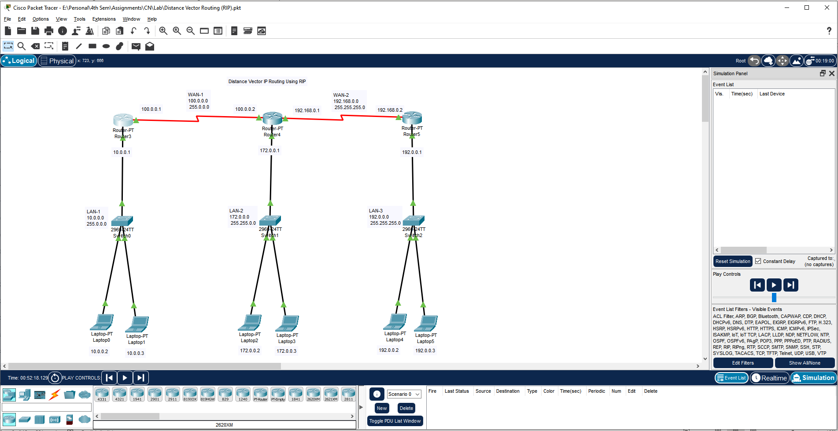

Assign the IP address for all PC and Router connected to the Switch 0.

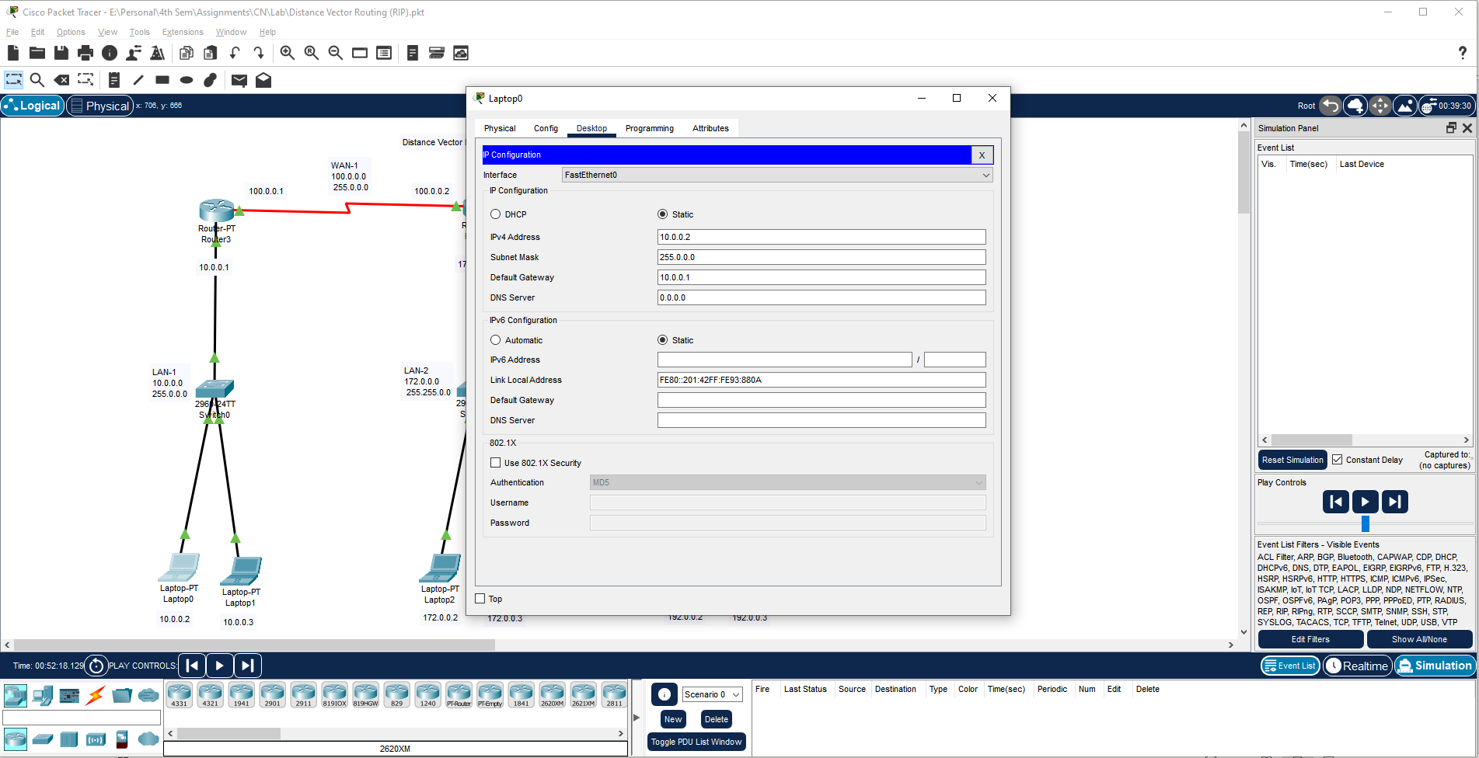

Assign the IP address for Router 3.

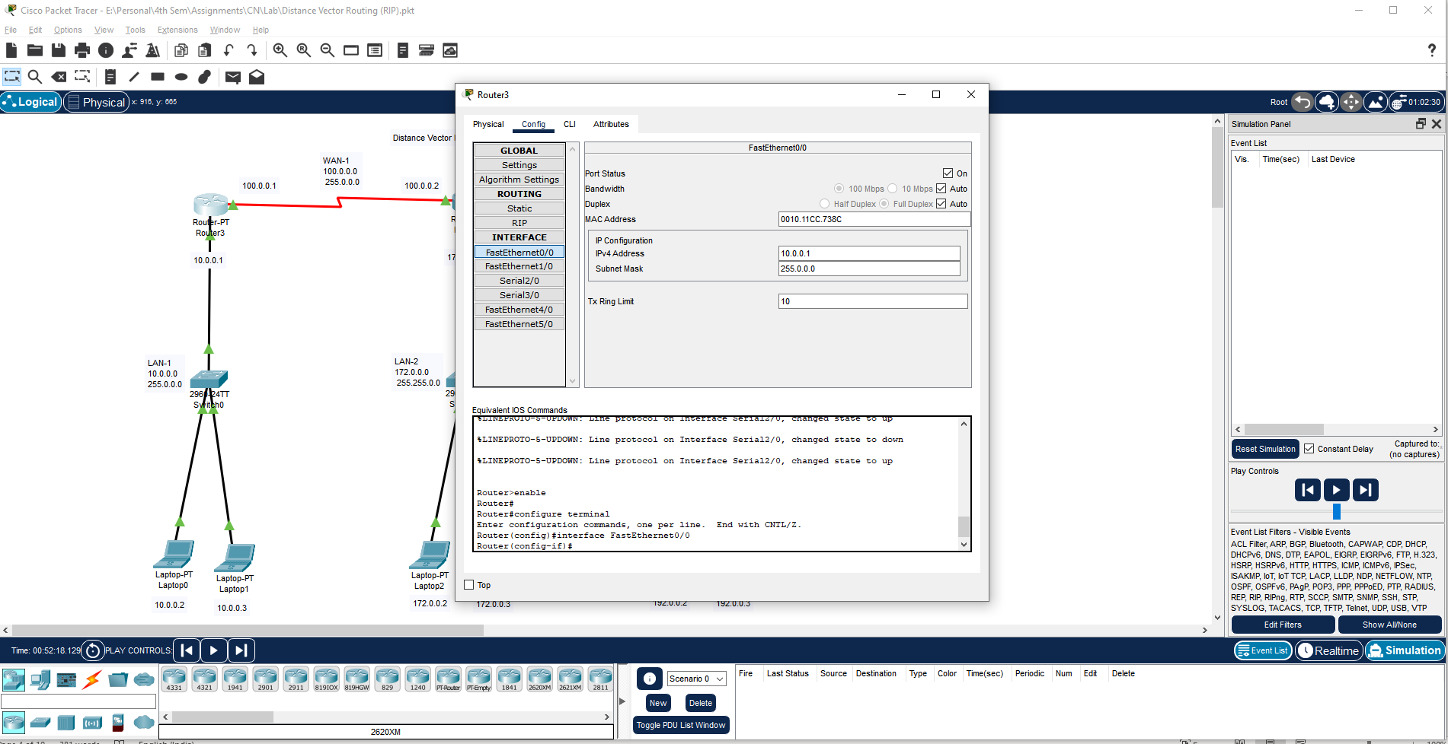

Assign the IP address for all PC and Router connected to the Switch 1.

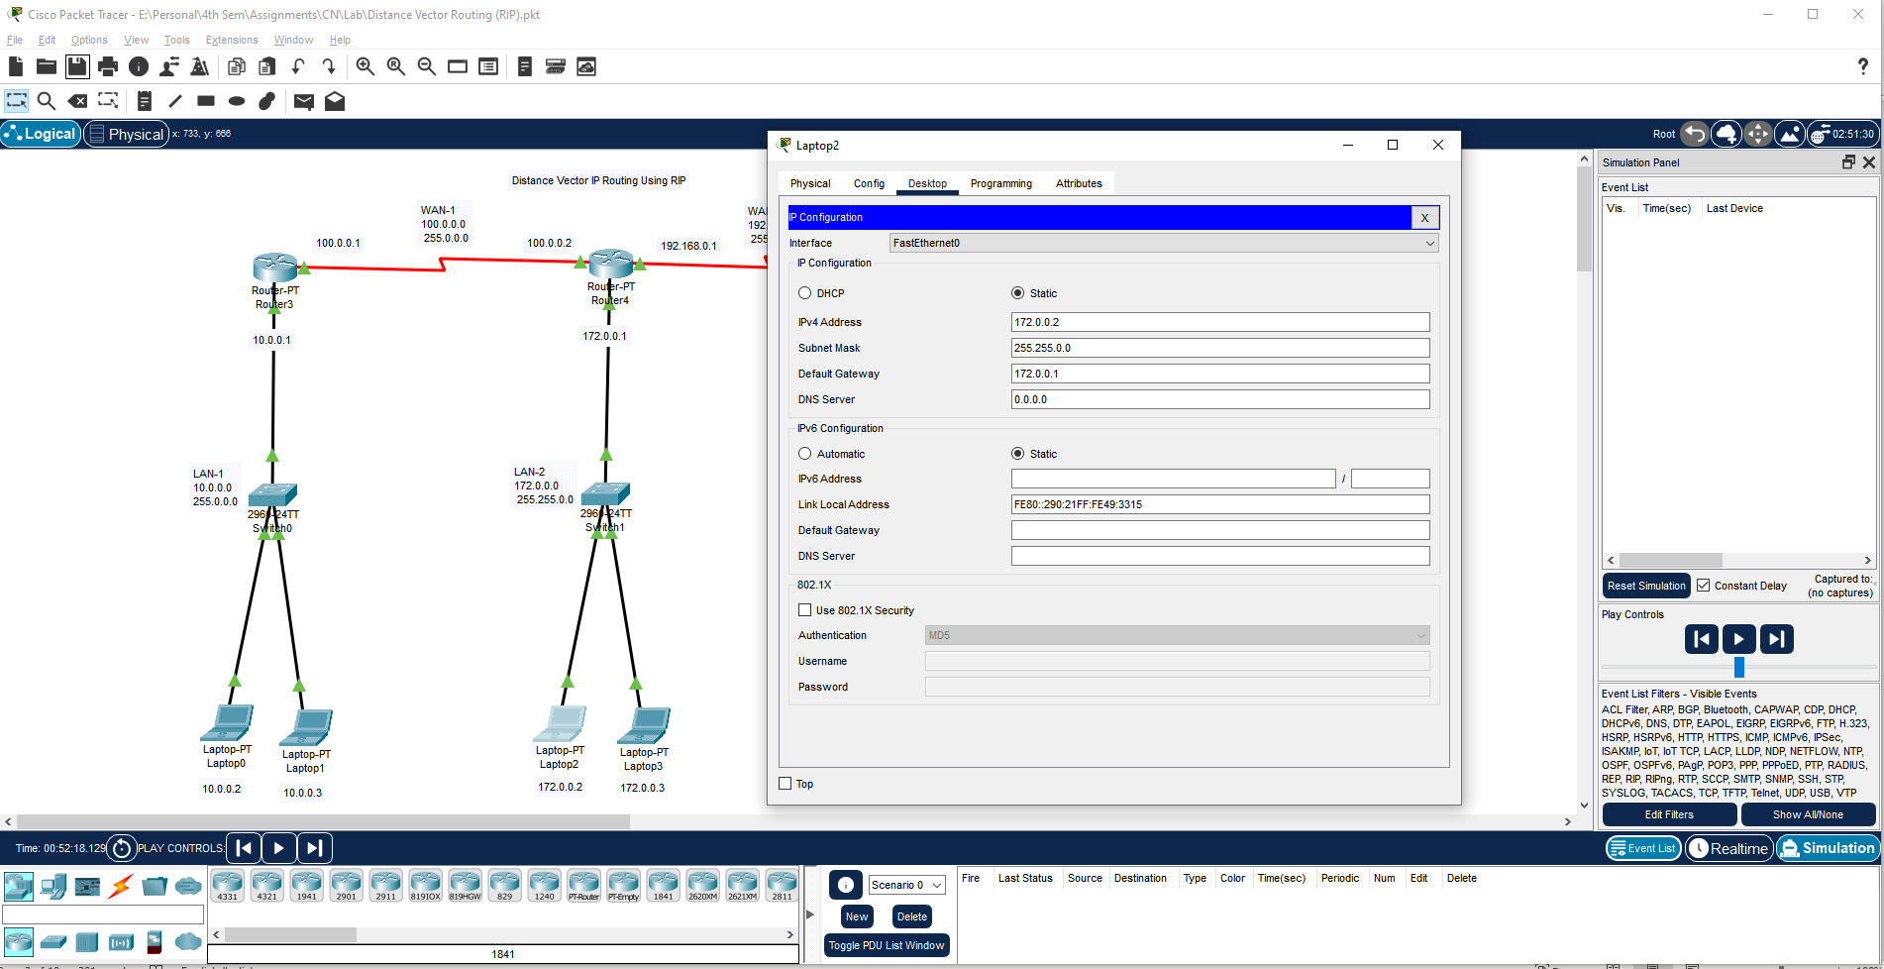

Assign the IP address for Router 4.

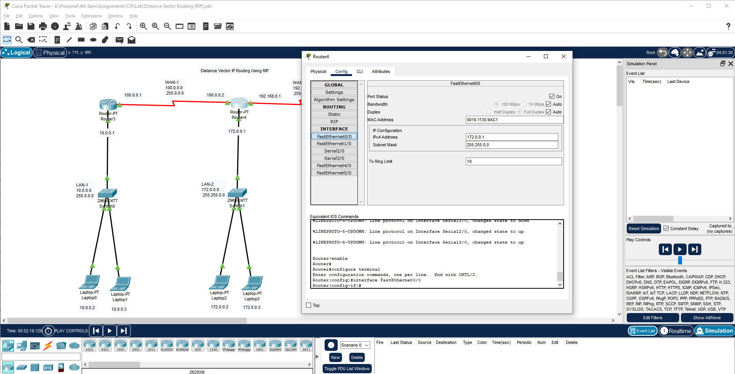

Assign the IP address for all PC and Router connected to the Switch 2.

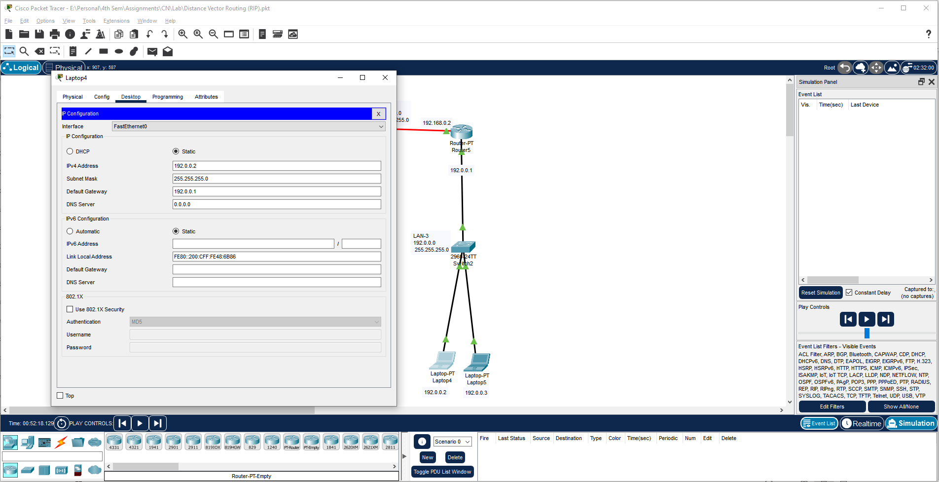

Assign the IP address for Router 5.

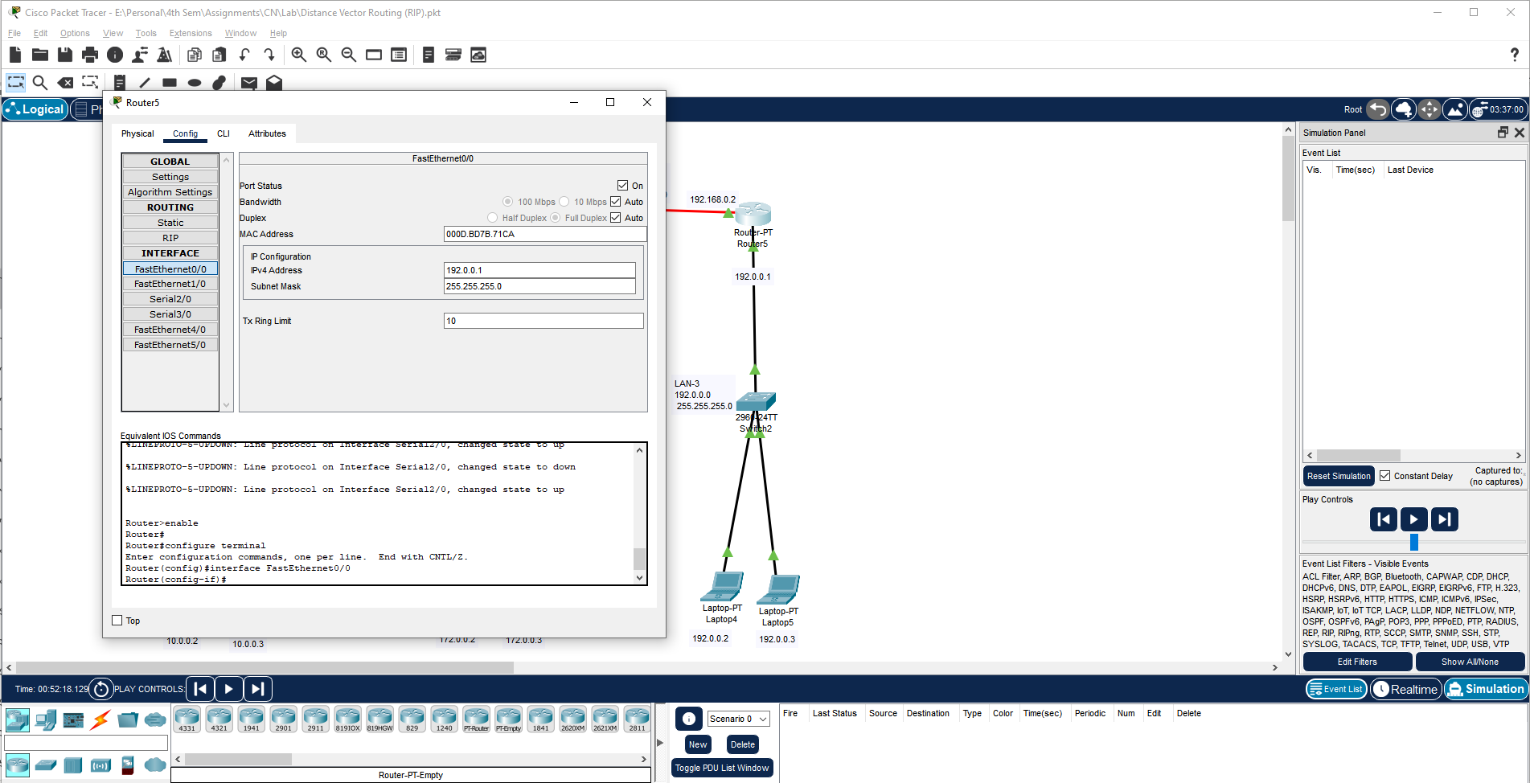

Assign the IP address for Serial Ports of Router 3.

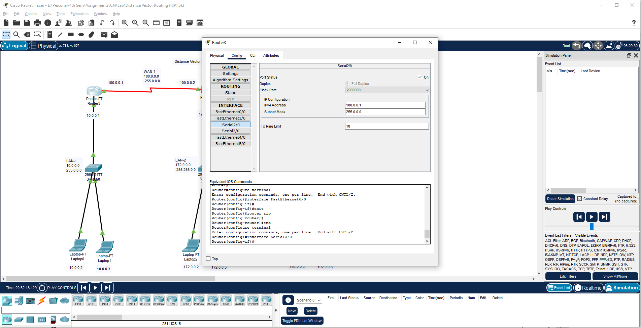

Assign the IP address for Serial Ports of Router 4.

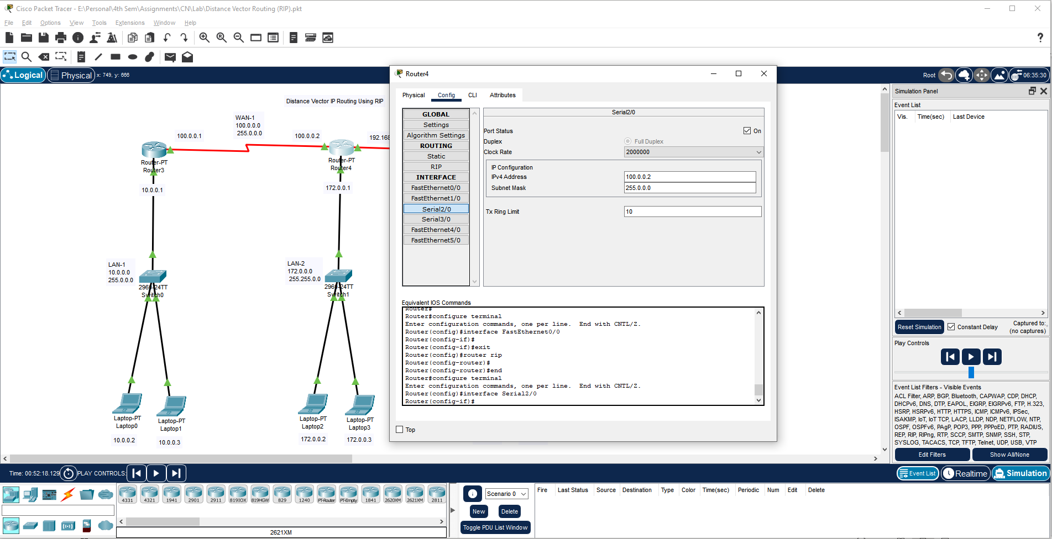

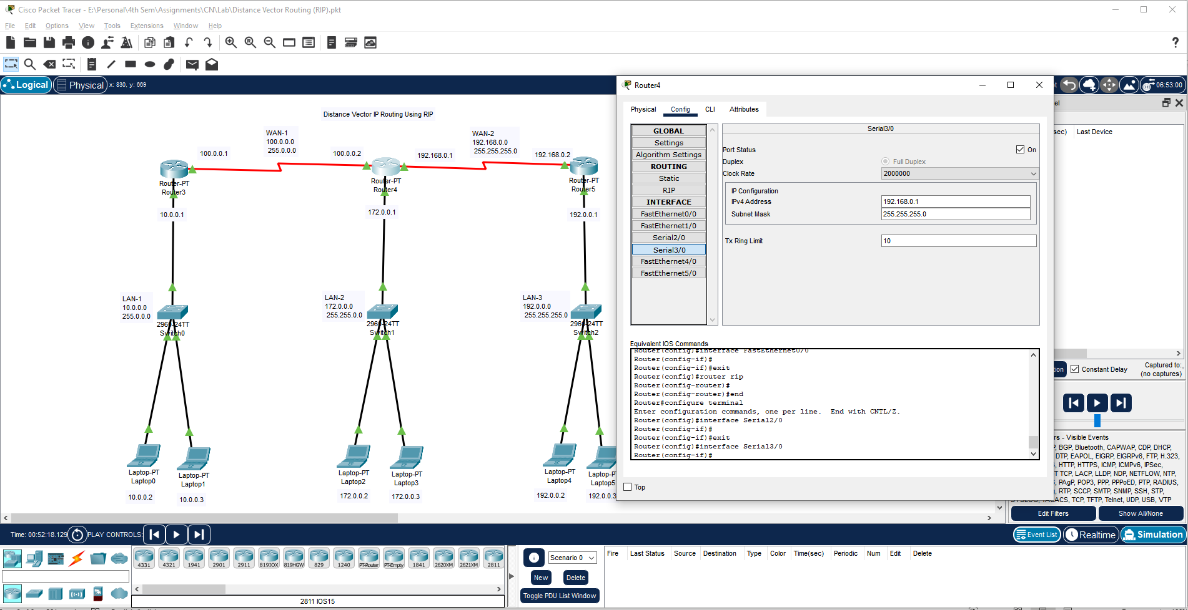

Assign the IP address for Serial Ports of Router 5.

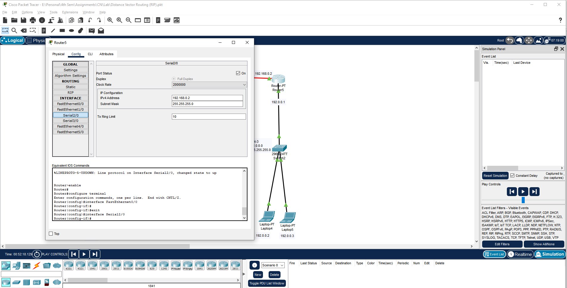

Add the RIP Network in Router 3.

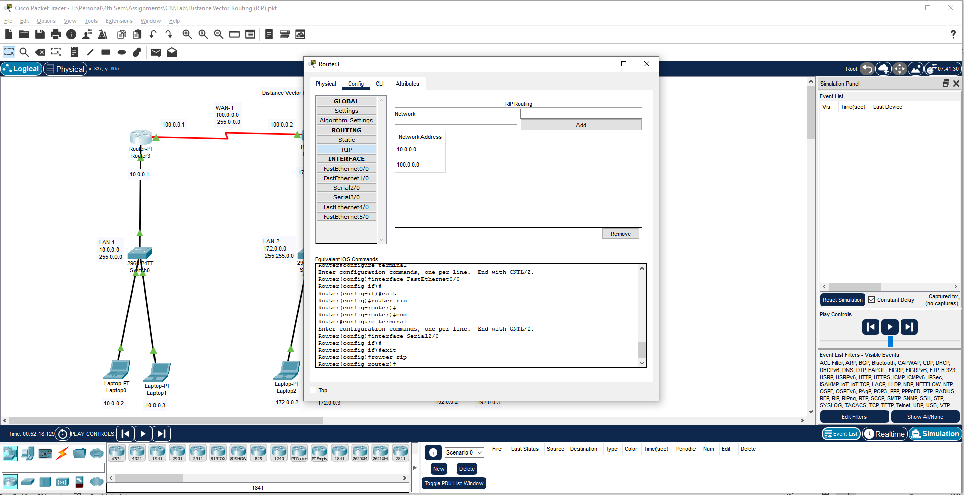

Add the RIP Network in Router 4.

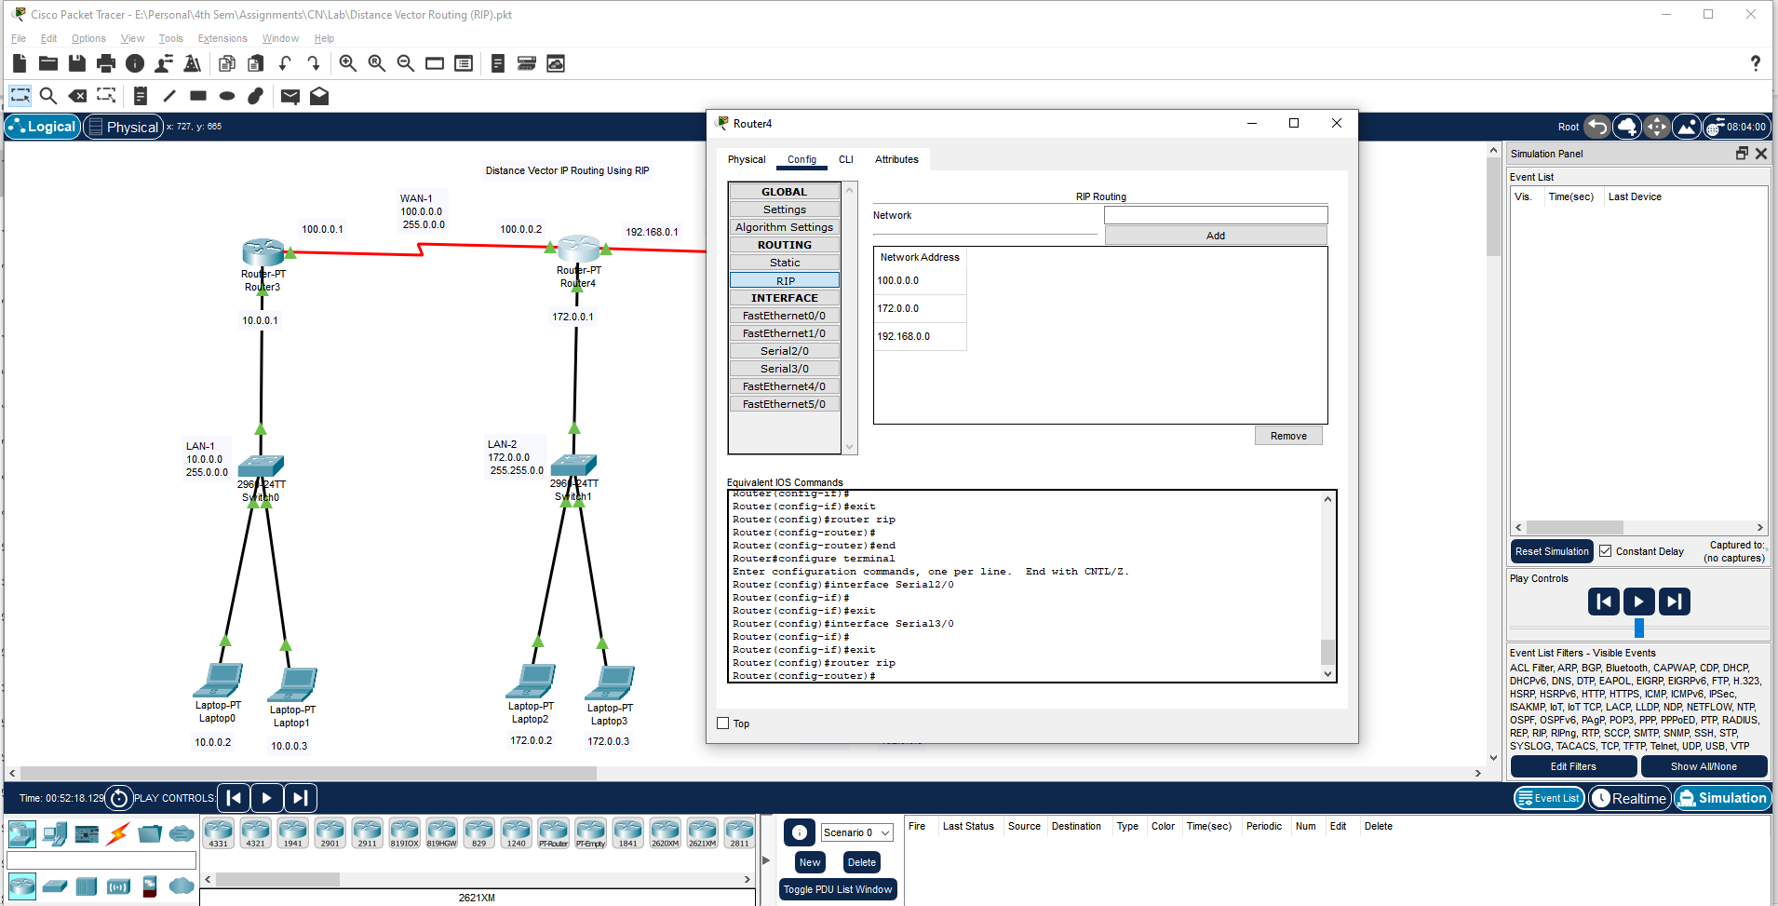

Add the RIP Network in Router 5.

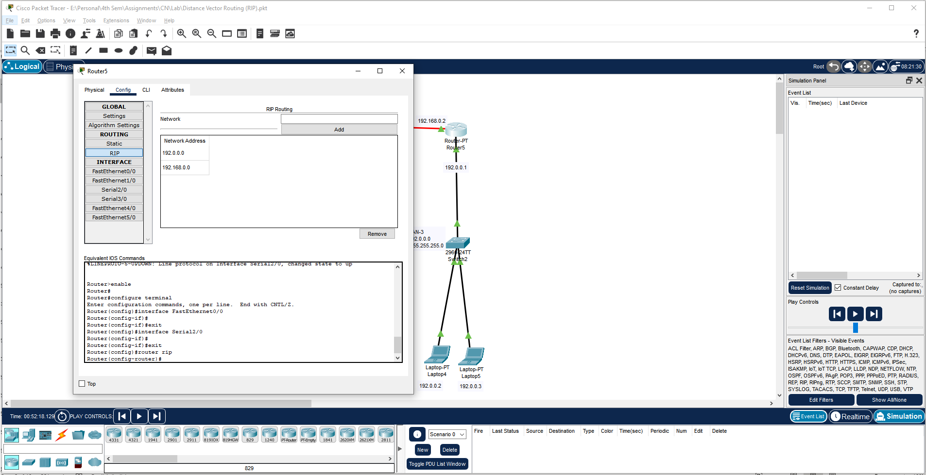

Send the Message in Realtime and Check the Connectivity.

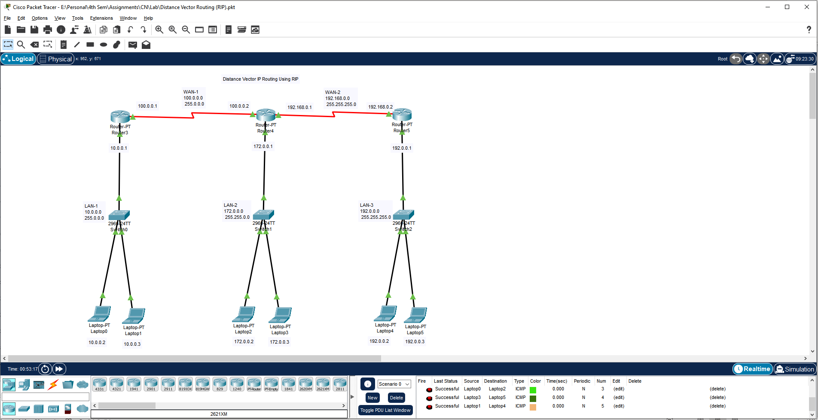

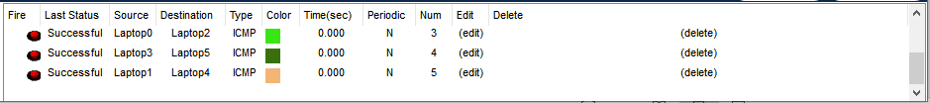

Send the Message in Simulation and See the Steps.

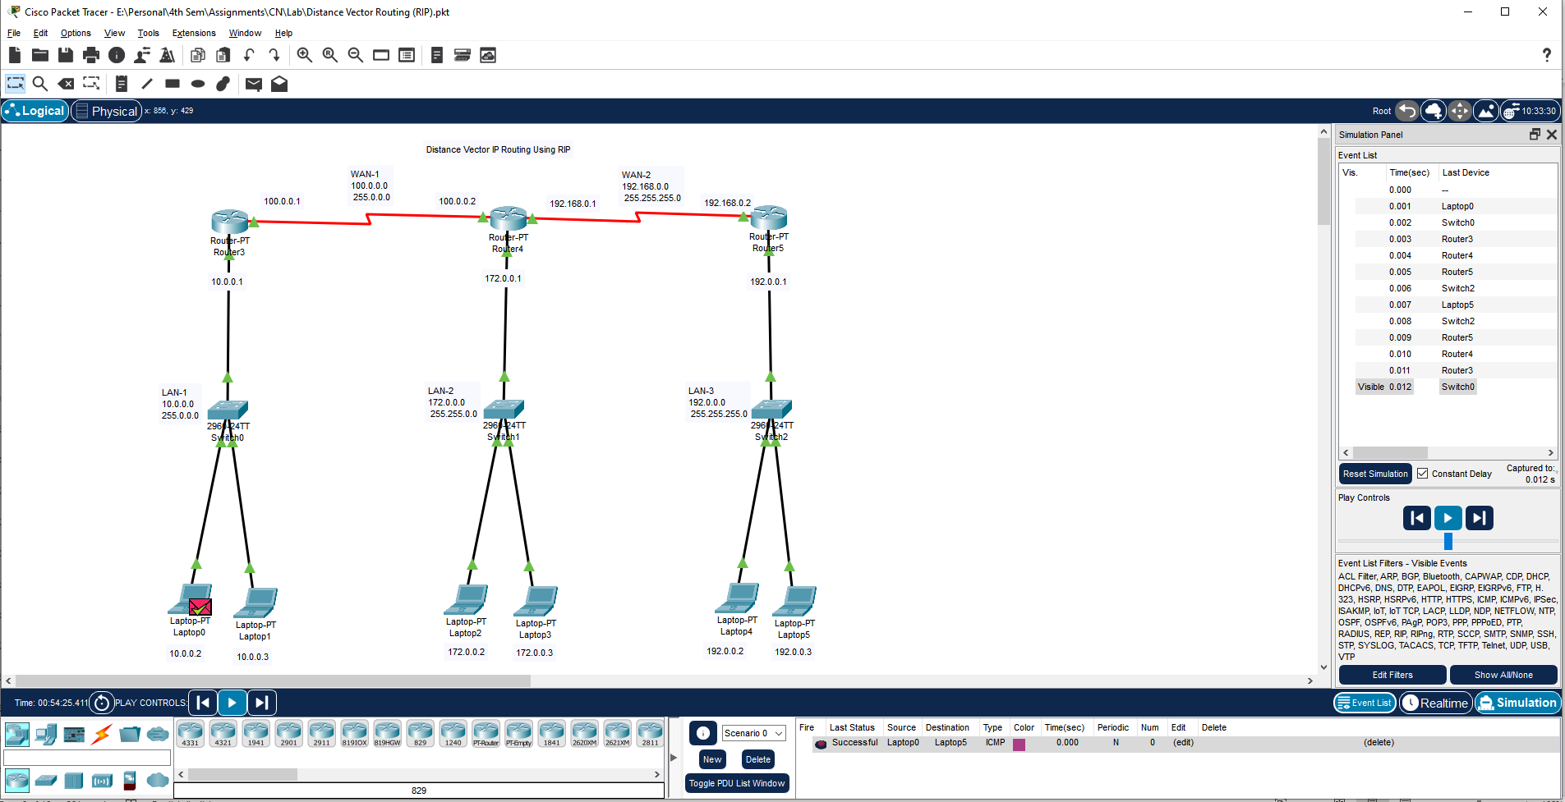

**Learning outcomes (What I have learnt):**

**1.** Understand working of Distance Vector Routing using RIP.

**2.** Create and Executed all process of Distance Vector Routing using RIP.

**Evaluation Grid (To be created as per the SOP and Assessment guidelines by the faculty):**

|  |  |  |  |
| --- | --- | --- | --- |
| Sr. No. | Parameters | Marks Obtained | Maximum Marks |
| 1. |  |  |  |
| 2. |  |  |  |
| 3. |  |  |  |
|  |  |  |  |